MongoDB
Installing MongoDB
PDF: https://medium.com/@LondonAppBrewery/how-to-download-install-mongodb-on-windows-4ee4b3493514
Video: https://www.udemy.com/course/the-complete-web-development-bootcamp/learn/lecture/12385728#questions

To check your MongoDB version via Terminal
$ mongo --version
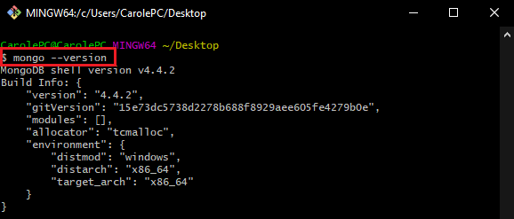
Note:
If it does not work and MongoDB is already installed in your OS, you have to make sure you have setup MongoDB correctly to be able to use it via terminal.

Setup a Shortcut to Launch Mongo/Mongod.exe from the Terminal (using Bash):
- Find out what version is your MongoDB.
Location: C:\Program Files\MongoDB\Server
MongoDB Version: 4.4 (rough version)

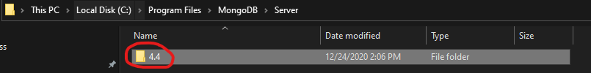

- Open terminal and go to your Home Folder.
$ cd ~ This navigates to your Home Folder
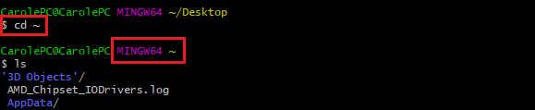
$ touch .bash_profile A hidden file we created and add file paths that will tell the terminal when it starts up, we want to use the access shortcut to Mongo/Mongod.exe
$ ls –a Make sure .bash_profile is created.
$ vim .bash_profile Open and edit this file using vim (command line based text editor)
(in vim)
Press “i” key to insert
alias mongod=
"/c/Program\ files/MongoDB/Server/<insert current mongodb version>/bin/mongod.exe"
alias mongo=
"/c/Program\ Files/MongoDB/Server/<insert current mongodb version>/bin/mongo.exe"
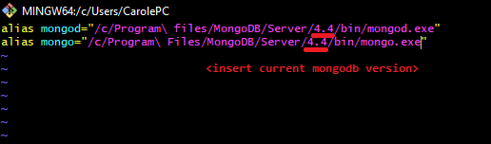
Press “:wq!” (colon)+wq! key to save and exit the file.

- Restart Terminal and check MongoDB Version.
$ mongo --version

Start Mongo Server
$ mongod In the end of the line, Port 27017 is now available.
The local database is being served in Port 27017.
Prompt is stopped when Mongod is running. Must create new terminal instance to tap into the Mongo Shell.
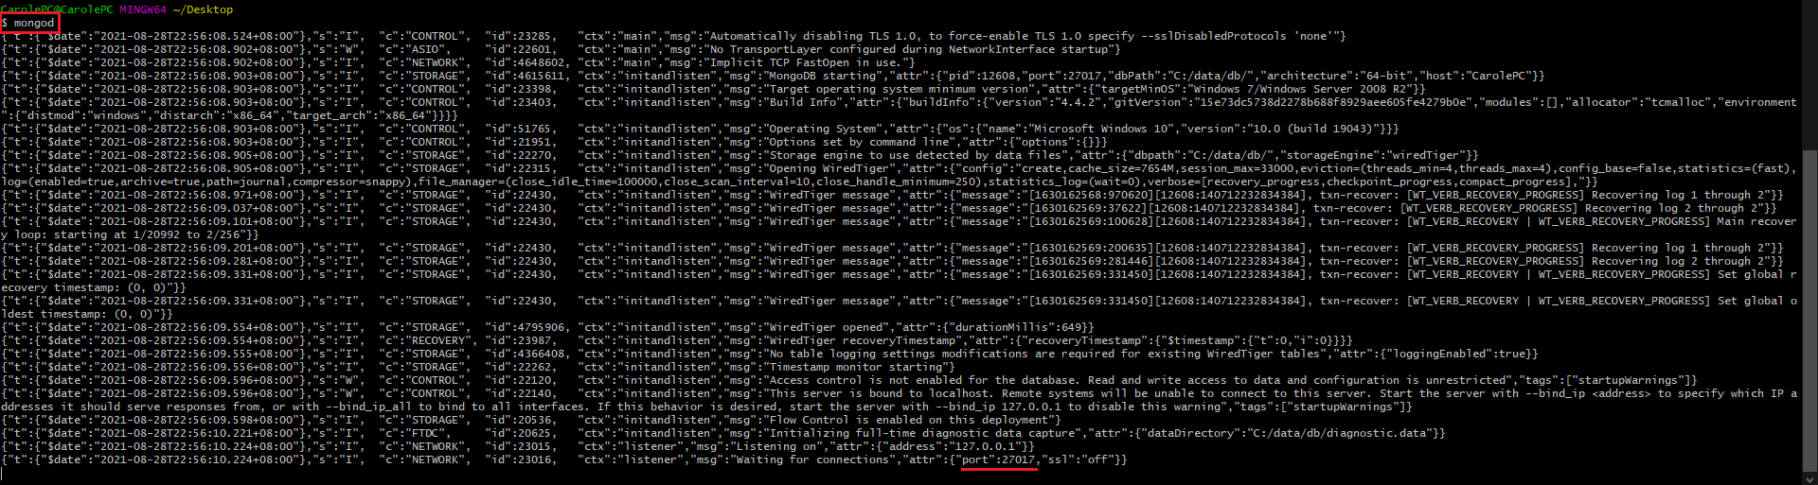

Mongo Shell
Basically just a way to interact with the MongoDB databases on the local system using the command line.
The MongoDB server must be installed and running before you can connect to it from the mongo shell.
The mongo shell is an interactive JavaScript interface to MongoDB. You can use the mongo shell to query and update data as well as perform administrative operations.

$ help Show helpful list while using Mongo Shell.
$ db Shows you the current database you are in.
$ show dbs Show dbs names. Won’t show empty user-created dbs.
$ show collections Show the collections(tables) in your current dbs.
$ use shopDB Creating a new empty database named “shopDB”. Database names are case sensitive.
$ use shopDB Creating a new empty database named “shopDB”.

Inserting Documents into a Collection
Source: https://docs.mongodb.com/manual/crud/
Terms:
- Collection: Table
- Document: A single data record / row.
db.collection.insertOne()
db.collection.insertMany()
By executing one of these lines, even if “collection” does not exist, by default, the collection table will be created with its documents (records) added.

Reading Documents in a Collection
db.collection.find()
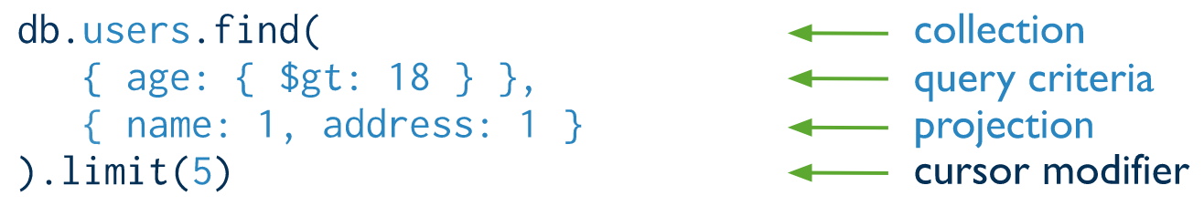
Projection parameter decides what column of data will be displayed in the results. 1 as True, 0 as False (or “do not display”).

Deleting a Database
You must first switch to the database you are about to delete.
db.dropDatabase()

Embedded Documents
Every document (record / row) is represented by a set of curly braces { … }.
Adding a document to another document is called “Embedding”.
reviews record is an embedded document associated with the products collection (table).
- db.products.insertOne(
- {
- _id: 3,
- name: "Pencil",
- price: 0.3,
- stock: 24,
- reviews: [
- {
- authorName: "John Carole",
- rating: 5,
- review: "Best pencil ever used."
- },
- {
- authorName: "Angela",
- rating: 3.3,
- review: "Eraser fell off easily."
- }
- ]
- }
- )

MongoDB NodeJS Native Driver
Link (v3.5): https://mongodb.github.io/node-mongodb-native/3.5/quick-start/quick-start/
Link (latest): https://docs.mongodb.com/drivers/node/current/quick-start/

Install MongoDB Driver Package
$ npm init Generates package.json and node_modules files.
$ npm install mongodb This command downloads mongodb package and dependencies required for its installation and saves them into the node_modules directory in your project, and records the dependency information in the package.json file you generated in npm init.

MongoDB Node.js driver allows Node.js applications to connect to MongoDB and work with data.
The Node.js driver is an interface through which you can connect to and communicate with MongoDB instances.
Very wordy and has lots of codes that needs to be written repeatedly that’s why Mongoose is chosen to develop the application more quickly and simply.
To run your application (app.js), you must make sure your MongoDB server is up and running.

Example of Working with The Native MongoDB Driver
- const MongoClient = require("mongodb").MongoClient;
- // “assert” has always something to do with testing.
- // Adding code to your MongoDB application has a lot of “assert”s that just validates the data entry and connection to your MongoDB Database.
- const assert = require("assert");

- // Connection URL
- const url = "mongodb://localhost:27017";

- // Database Name: FruitsDB
- const dbName = "FruitsDB";

- // Create a new MongoClient
- const client = new MongoClient(url);

- // Use connect method to connect to the Server
- client.connect(function (err) {
- assert.equal(null, err);
- console.log("Connected successfully to server.");

- // If DB does not exist, this code will by defualt, create one.
- const db = client.db(dbName);

- insertDocuments(db, function () {
- findDocuments(db, function () {
- client.close();
- });
- });
- });

- const insertDocuments = function (db, callback) {
- console.log("INSERTING DOCUMENTS");
- // Get/Create the collection/table name
- // If collection does not exist, creates one by default.
- const collection = db.collection("fruits");
- // Insert some documents/records
- collection.insertMany(
- [
- {
- name: "Strawberry",
- sweetnes: 7,
- review: "Sweet but not too much.",
- },
- {
- name: "Apple",
- sweetnes: 6,
- review: "Not good when eating it on an empty stomach.",
- },
- {
- name: "Mango",
- sweetnes: 10,
- review: "I just love it",
- },
- ],
- function (err, result) {
- console.log("Assert: Check if inserted documents are null.");
- // Validate to ensure there are no errors when inserting the documents.
- assert.equal(err, null);
- console.log("Assert: Check if 3 documents are added.");
- // Ensures there are 3 results inserted into the collection.
- console.log("Print 'result' return value: ", result);
- // assert.equal(3, result.result.n); //Code not supported anymore. Updated to the one below.
- assert.equal(3, result.insertedCount);
- // assert.equal(3, result.ops.length); //Code not supported anymore. Updated to the one below.
- assert.equal(3, Object.keys(result.insertedIds).length);
- console.log("Inserted 3 documents into the collection");
- callback(result);
- }
- );
- };

- const findDocuments = function (db, callback) {
- console.log("FIND DOCUMENTS (PRINT ALL)");
- // Get the documents collection
- const collection = db.collection("fruits");
- // Find some documents
- collection.find({}).toArray(function (err, docs) {
- assert.equal(err, null);
- console.log("Found the following records:");
- console.log(docs);
- callback(docs);
- });
- };

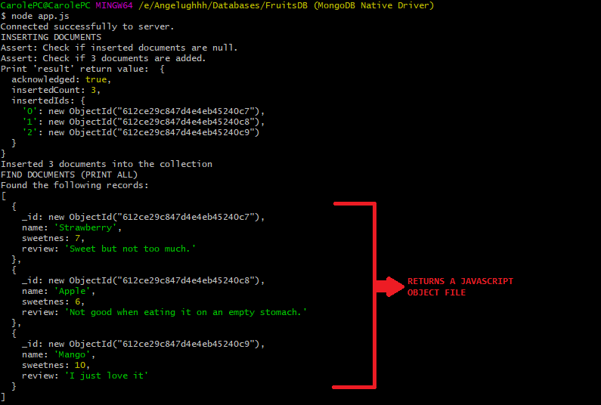
MongoShell displays its documents as a JSON file. (below)

Mongoose
Link: https://mongoosejs.com/docs/index.html
Mongoose is an ODM (Object Document Mapper/Modeling).
Mongoose, like Mongod, is also a package.
Like how we used DOM (Document Object Model) which was longer and more complex to type. We used JQuery to make commands a lot shorter and simpler. Mongoose function similarly to JQuery.
Uses NodeJS (which speaks the language of JavaSript objects) to speak to MongoDB(which speaks in the language of documents, databases, collections, etc.).

Install Mongoose Package:
$ npm install mongoose
- const mongoose = require("mongoose");

- // CONNECTING TO A SPECIFIC MONGODB DATABASE
- // mongodb://localhost:27017 <-- This specifies the port where we can access the MongoDB server.
- // add a /<database name> to specify what DB to create/connect to.
- mongoose.connect("mongodb://localhost:27017/FruitsDB", {
- // (node:12488) DeprecationWarning: current URL string parser is deprecated, and will be
- // removed in a future version.
- // To use the new parser, pass option { useNewUrlParser: true } to MongoClient.connect.
- useNewUrlParser: true,

- // (node:12488) [MONGODB DRIVER] Warning: Current Server Discovery and Monitoring engine
- // is deprecated, and will be removed in a future version. To use the new Server Discover
- // and Monitoring engine, pass option { useUnifiedTopology: true } to the MongoClient
- // constructor.
- useUnifiedTopology: true,
- });

- // CREATING A SCHEMA FOR THE COLLECTION (TABLE)
- // Structuring data to be saved in the MongoDB database.
- // Will be the foundation when adding every <table name> document to the db.
- const fruitSchema = new mongoose.Schema({
- name: {
- type: String,
- required: [true, "No name was specified. Data insertion halted."],
- },
- sweetness: {
- type: Number,
- min: 1,
- max: 10,
- },
- review: String,
- });

- // CREATING FRUIT COLLECTION (TABLE) MONGOOSE MODEL
- // Use the schema to create a new Mongoose Model.
- // 1st Parameter (type string and must be singular): name of the collection that will comply
- // with the FruitSchema.
- // Mongoose way is to specify the singular name of your collection and it will automatically
- // convert your string into plural form and all lower cased then create your collection.
- // 2nd Parameter (type mongoose.Schema): structure your 1st parameter must follow.
- const Fruit = mongoose.model("Fruit", fruitSchema);

- // CREATING A FRUIT DOCUMENT
- // Creating a "fruit" document from the "Fruit" Model
- const fruit = new Fruit({
- name: "Oreo",
- sweetness: 10,
- review: "Just perfect!",
- }); // ms ev save

- // Tells Mongoose to save your fruit document, inside the Fruit collection, inside the FruitsDB.
- fruit.save();

- const strawberry = new Fruit({
- name: "Strawberry",
- sweetness: 6,
- review: "Not too sweet though.",
- });

- const banana = new Fruit({
- name: "Banana",
- sweetness: 7,
- review: "Sweet but sick of it.",
- });

- const dragonfruit = new Fruit({
- name: "Dragon Fruit",
- sweetness: 5,
- review: "Confusing.",
- });

- // INSERTING MANY DOCUMENTS INTO A COLLECTION
- Fruit.insertMany([strawberry, banana, dragonfruit], (error) => {
- if (error) {
- console.log("Error has occurred:(insert) ", error);
- } else {
- console.log("Successfully added new fruits to the database.");
- }
- });

- Fruit.updateOne(
- { _id: "612d2473d2bc04349c38c6a9" },
- {
- name: "Only Oreo",
- sweetness: 1,
- },
- (err) => {
- if (err) {
- console.log("Error updating: ", err);
- } else {
- console.log("Successfully Updated.");
- }
- }
- );

- Fruit.deleteOne({ name: "Only Oreo" }, (err) => {
- if (err) {
- console.log("Error deleting document.");
- } else {
- console.log("Successfully Deleted.");
- }
- });

- // Encountered Error: (node:83559) UnhandledPromiseRejectionWarning:
- // MongoInvalidArgumentError: Method "collection.find()" accepts at most two arguments
- // Solution:
- // Just run "npm uninstall mongoose" <= to uninstall the current mongoose version 6.
- // Then run "npm i mongoose@5.13.8" <= installs the version that will fix the issue.
- Fruit.find((err, fruitsRet) => {
- if (err) {
- console.log("Error has occurred:(find) ", err);
- } else {
- fruitsRet.forEach((temp) => {
- console.log("Name:", temp.name, temp.sweetness);
- });

- // Good practice: close the connection when you're done.
- mongoose.connection.close();
- }
- });

- const personSchema = new mongoose.Schema({
- name: {
- type: String,
- required: true,
- },
- age: {
- type: Number,
- min: 1,
- },
- favoriteFruit: fruitSchema,
- });

- const Person = mongoose.model("Person", personSchema);

- const person = new Person({
- name: "Amy",
- age: 12,
- favoriteFruit: strawberry,
- });

- person.save();

- Person.updateOne({ name: "John" }, { favoriteFruit: banana }, (err) => {
- if (err) {
- console.log("Error has occurred when updating.");
- } else {
- console.log("John has now a new favorite fruit.");
- }
- });
Problem: In Line 109 you can encounter this error:
Solution:
Execute the following in your terminal
$ npm uninstall mongoose to uninstall the current mongoose version.
$ npm i mongoose@5.13.8 installs the version that will fix the issue

Problem: The find function does not include the most recently added Doc
Answer: JavaScript is a single-threaded programming language which means only one thing can happen at a time. That's where asynchronous JavaScript comes into play. Using asynchronous JavaScript (such as callbacks, promises, and async/await), you can perform long network requests without blocking the main thread.
In short, even before Fruit.insertMany(...) 's data is added to the MongoDB database, the program still continued executing towards Fruit.find(...).
Fruit.find(...) then proceeded to print the records found in the MongoDB database at that particular point in time where Fruit.insertMany(...) has not finished posting the latest record of data, therefore, making it seem like your recent data has not been posted.
Problem: If you're getting favicon.ico generated on get "/" Solution inside!
Answer: Add this line of code on the header.ejs, just below your CSS link
<link rel="icon" href="data:,">
By default, browsers will try on their own to find the favicon.ico in the root directory by making a GET request to /favicon.ico. When you navigate to localhost:3000/work the browser makes another request to localhost:3000/favicon.ico to try to find the favicon for the page. This matches our app.get("/:param", callback()) and both "work" and "favicon.ico" get printed to the console.

By adding <link rel="icon" href="data:,"> to the top of the header.ejs file, you're instructing the browser to not follow its default behavior of looking for the icon in the root directory, but instead to try to load it from the specified Data URL (which in this case is empty).

MongoDB Atlas
Background
http://localhost:3000
http (hypertext transfer protocols): a set of rules that govern how we transfer data across the internet to access web pages

mongodb://localhost:27017
mongodb: a set of rules that determines how to access data in a MongoDB database.

Currently, we are using our local computer as a server to serve up information and data in our website. We used
NodeJS (http://localhost:3000) for the backend
MongoDB (mongodb://localhost:27017) as the database
and both are all hosted in the local computer, thus, the “localhost” keyword.

We can use a Data Server (Heroku) that is online 24/7 and attached to the internet backbone to host our NodeJS Server and be able to deliver our website wherever it is requested across the internet. As for the database, Heroku only supports Postgre SQL and not MongoDB so we need to setup to another server that is capable of hosting MongoDB databases, this is where the MongoDB Atlas comes in. MongoDB Atlas is going to host and serve up our database whenever it is needed. Eventually, our NodeJS app in Heroku will be able to make requests to our database hosted in MongoDB Atlas Cloud Service and be able to perform CRUD.
Web-based Address:
Server: Heroku
NodeJS: http://yourapp.herokuapp.com
Server: MongoDB Atlas
MongoDB: mongodb://cluster0.mongodb.net:27017

Terminologies
Cluster
A mongodb cluster is the word usually used for sharded cluster in mongodb.
The main purposes of a sharded mongodb are:
- Scale reads and writes along several nodes
- Each node does not handle the whole data so you can separate data along all the nodes of the shard. Each node is a member of a shard (which is a replicaset, see below for the explanation) and the data are separated on all shards.

Setup
  - Sign up to https://www.mongodb.com/cloud/atlas/register
  - Select and use a “shared” (free) cloud database
  - Create a shared cluster:
Clout Provider and Region: AWS
Region: N. Virginia (free tier, no cc needed)
Cluster Tier: Shared MO Sandbox (make sure price is $0)
  - While waiting for you cluster to finish setting up, add a new user for access rights.
Authentication Method: Password
Username: admin-angela
Password: Test123
Database User Privilege: Atlas Admin
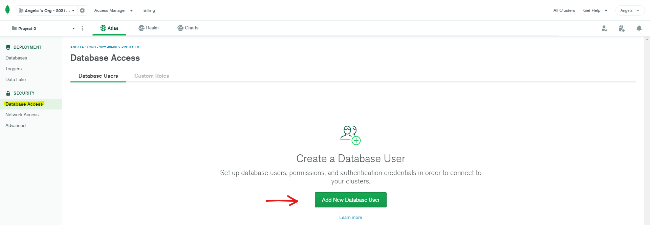
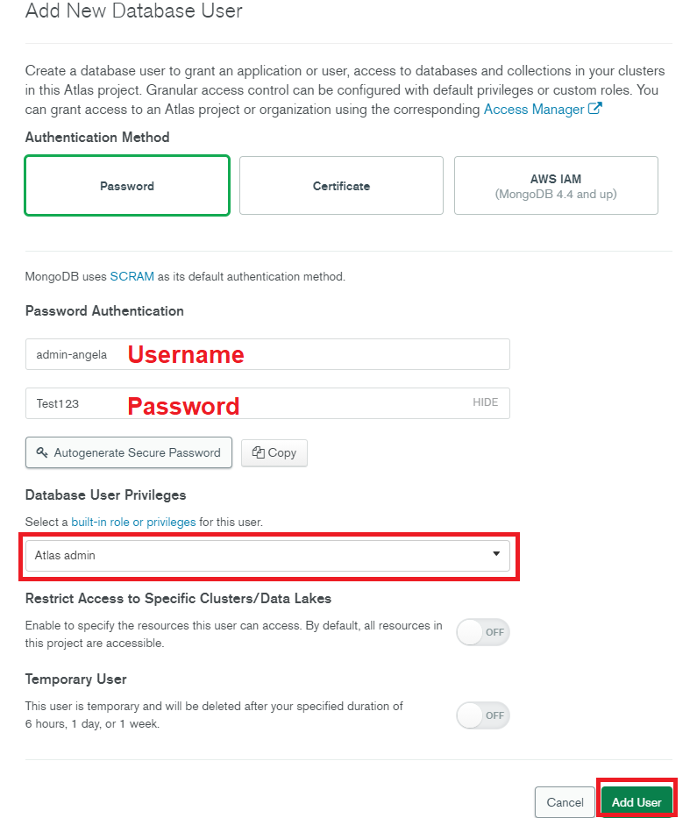
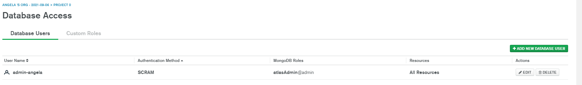
These MongoDB Users have the credentials which we’ll need to communicate with the Database in MongoDB Atlas Server002E
  - Setup your IP Access List (Security Network Access IP Access List)
Click on Allow Access From Anywhere
Access List Entry: 0.0.0.0/0
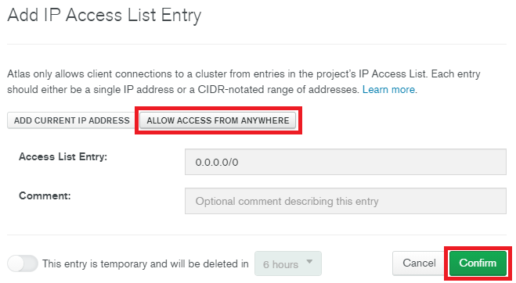

  - Going back to your Deployment Databases, connect to your cluster
Click Connect
Connect with the MongoDB Shell
I have the MongoDB Shell Installed
Select your MongoDB Shell version (or the nearest version to yours)
Test connection string in your Hyper Terminal (copy and paste)

  - dsaff

asdfasdf

